OPERATION INSTRUCTION FOR PROTOTYPE

This prototype demonstrates the most essential functionalities of our proposed tool. Therefore only limited aspects of the tool are implemented.

In order to successfully run this prototype, the user will need to follow the following steps:

1. Click on “+New Project”
2. Select the top template and click “OK”
3. Click on “Clip art” on the top menu
4. Select the rectangle chat bubble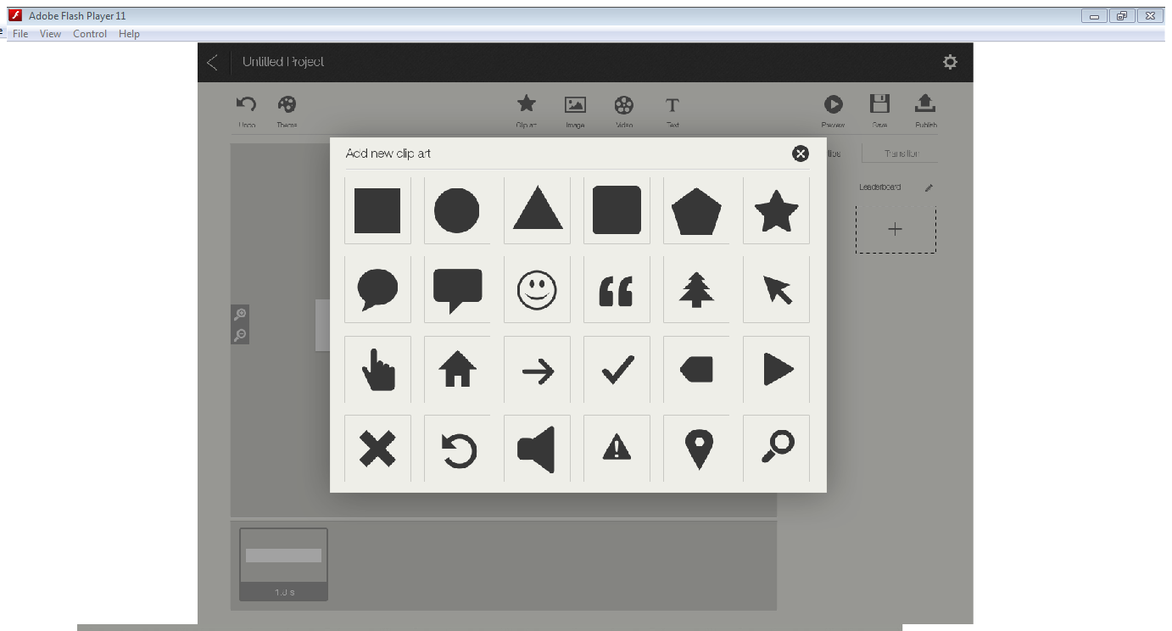
5. Select the chat bubble on the canvas to see its properties

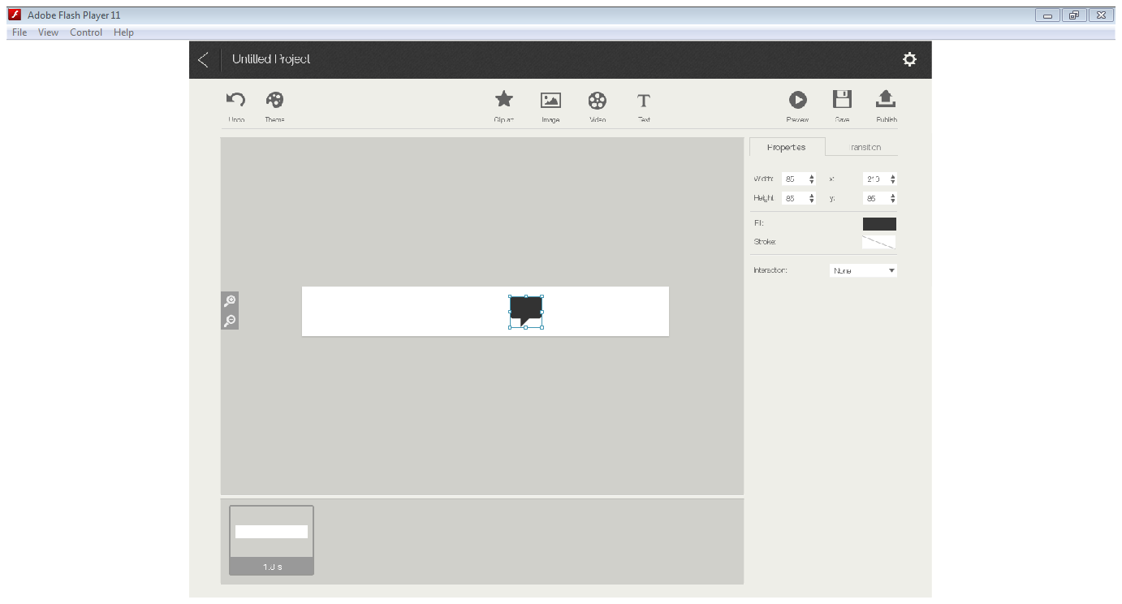

1. Click on “Transition” tap on the properties panel to add transition
2. Click on “add new transition”
3. Select on first transition (top left)

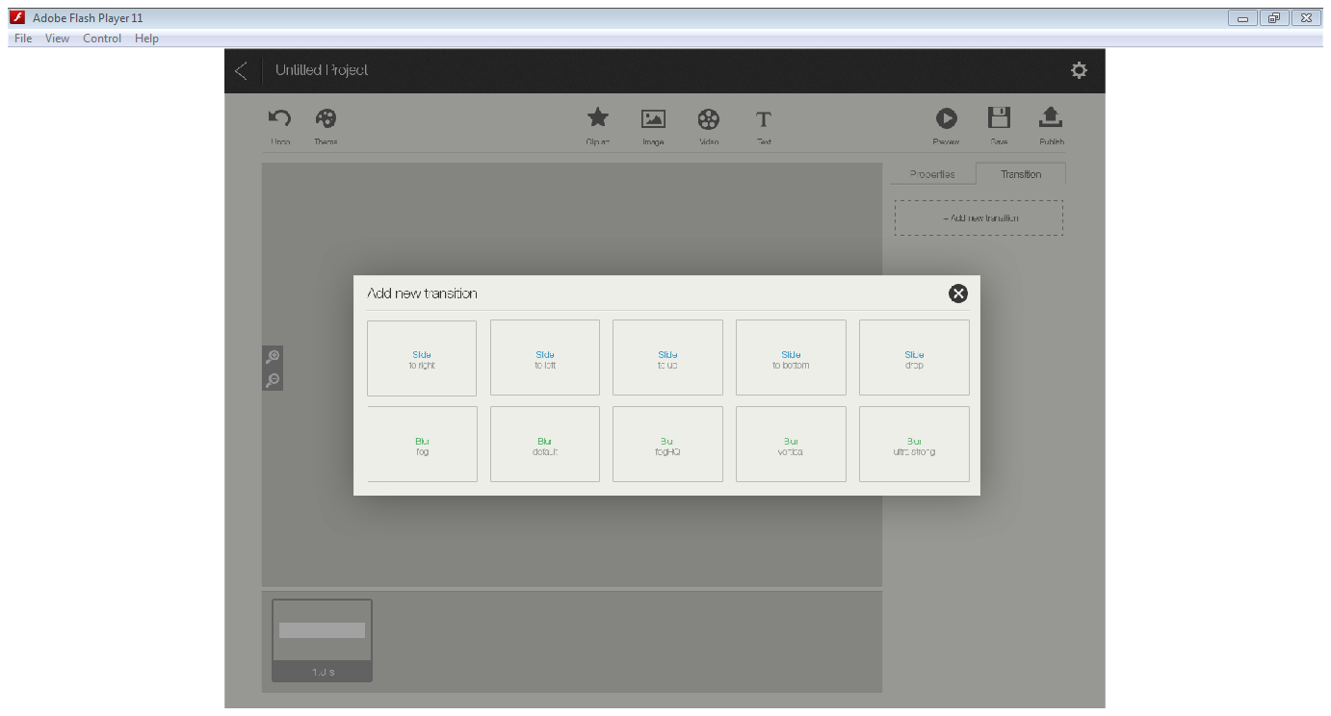

1. Now transition is added, the user can preview the transition by clicking on the “preview” button on the top menu.